# A

Project report on Matrimony website system

“Find Your Perfect Match Online”

Bachelor of business administration(computer application)

Submitted by:

1.chavan prajkta dilip

2.mhaske abhishek sunil

3.jadhav kedar krishnat

Head of Department:- Project Guide:

Prof.Tanpure .V.R. 1) Prof.Tanpure .V.R

2)Prof.Dhumal.Madam

ACKNOWLEDEMENT

We take this opportunity to express our sincere gratitude to all those who helped us in various capacities in undertaking this project and devising the report. We are privileged to express our sense of gratitude to our all respected teachers whose unparalleled knowledge, moral fiber and judgment along with his knowhow, was an immense support in completing the project.We are also grateful to Prof.Tanpure .V.R. ,the Head of Department, Bachelor Of Business Administration (Computer Application), for the brainwave and encouragement given. We take this opportunity also to thank our friends and contemporaries for their cooperationand compliance.

1.chavan prajkta dilip

2.mhaske abhishek sunil

3.jadhav kedar krishnat

# Pune District Education Association

### Shankarrao bhelake college, nasarapur.

Department of Computer Application  ***Certificate***

This is to certify that Mr./Miss ---1.chavan prajkta dilip 2.mhaske abhishek sunil 3.jadhav kedar krishnatof class SY(BBA)CA has completed her/his project work entitled.”lagnabandan website”AS a part of BBA (Computer Application) SEM- 4 Curriculum. During that Academic year 2023-2024

Project Guide Head of Department 1)Prof.Tanpure.V.R. Prof.Tanpure.V.R.

2)Prof.Dhumal Madam

Internal Examiner External Examiner

Date: - / / 2024

Introduction

* Welcome to Lagnabandan, your premier destination for finding the perfect life partner. In a world where time is precious and connections are paramount, Lagnabandan offers a modern solution to the age-old quest for love and companionship.
* At Lagnabandan, we understand the significance of finding someone who not only shares your values and aspirations but also complements your journey in life. With our user-friendly platform and comprehensive services, we strive to make the process of finding your soulmate both efficient and enjoyable.
* Our mission at Lagnabandan is simple: to empower individuals in their pursuit of lifelong happiness. Whether you're seeking a partner who shares your cultural background, professional ambitions, or personal interests, our diverse community of members ensures that you'll find someone who resonates with you on a profound level.
* With advanced search filters, intuitive communication tools, and a commitment to user privacy and security, Lagnabandan offers a seamless and personalized matchmaking experience. Our success stories stand as a testament to the effectiveness of our platform in bringing together compatible individuals and fostering meaningful relationships.
* Join us on this journey of discovery and connection. Whether you're embarking on your first steps in the world of online matchmaking or seeking to enrich your existing relationships, Lagnabandan is here to support you every step of the way.
* Let Lagnabandan be your guide as you navigate the exhilarating landscape of love and companionship. Start your journey with us today, and unlock the endless possibilities that await you in the realm of matrimonial bliss.
* Welcome to Lagnabandan – where every connection is a step closer to forever.

**About Lagnabandan**

Welcome to Lagnabandan, your trusted companion in the journey to find love and companionship. Founded with the vision of bringing hearts together and fostering meaningful connections, Lagnabandan stands as a beacon of hope for individuals seeking their perfect life partner.

**Our Mission**

At Lagnabandan, our mission is simple yet profound: to empower individuals in their quest for lifelong happiness. We believe that everyone deserves to find a partner who not only shares their values and aspirations but also enriches their lives in ways they never imagined.

**Get Started Today**

Join Lagnabandan today and embark on the journey to finding your soulmate. Whether you're new to the world of online matchmaking or seeking to enhance your existing relationships, Lagnabandan is here to support you every step of the way.

Experience the joy of discovering meaningful connections and unlock the infinite possibilities that await you at Lagnabandan. Your journey to matrimonial bliss starts here.

“Welcome to Lagnabandan – where every connection is a step closer to forever.”

Scope of lagnabandan website

The scope of a matrimony website encompasses providing a platform for individuals to create profiles, search for compatible partners based on criteria such as age, religion, caste, profession, etc., communicate with potential matches, and eventually find a life partner. These platforms may also offer additional services such as matchmaking assistance, profile verification, wedding planning resources, and community forums. The scope extends to catering to diverse cultural and religious preferences while facilitating meaningful connections and ultimately fostering marriages. Additionally, matrimony websites can serve as a hub for social networking, relationship advice, and support within the community.

Objectives

1. **Facilitating Matchmaking**: The primary objective could be to facilitate the process of finding compatible life partners for users, providing them with a platform to search for and connect with potential matches based on their preferences, interests, and criteria.
2. **User Engagement**: Encouraging user engagement by offering various interactive features such as profile creation, browsing through profiles, sending messages, and expressing interest in potential matches. This helps users actively participate in the matchmaking process.
3. **Ensuring Privacy and Security**: Ensuring the privacy and security of user data and communications is crucial. Your website should implement robust security measures to protect users' personal information
4. and provide options for controlling visibility of their profiles and communication.
5. **Continuous Improvement**: Continuously gathering user feedback and making improvements to the website based on user suggestions and evolving trends in the matchmaking industry to enhance user experience and satisfaction.
6. **Mobile Accessibility**: Ensuring that the website is accessible and user-friendly on mobile devices, as many users prefer to browse and interact with such platforms on smartphones and tablets.
7. **Monetization**: If applicable, generating revenue through subscription plans, premium features, advertising, or other monetization strategies could be an objective to sustain the operation and growth of the website

Software USE for the project –

1. VS studio

2. Web browser (Google Chrome)

3. Xammp local server

Language used Frontend languages –

1. HTML

2. CSS

3. Bootstrap

Backend languages –

1. PHP

2. JavaScript

3. jQuery

4. SQL

Proposed System

❖ Each Accommodation available units and all the unit facilities are also available at the click of a mouse.

❖ The registration of new guest is online house new guest can make them they convenient for registration process on the basic of 24x7x326days.

❖ The Units can be booked by the Registered guest irrespective of the Geographical barriers. The Guest are provided with up to minute information related to the unit availability and their status. From their convenient place.

❖ The decision process in more faster and more consistent.

❖ The guest have information at their demand related to any unit status of their own unit booking status.

ER DIAGRAM

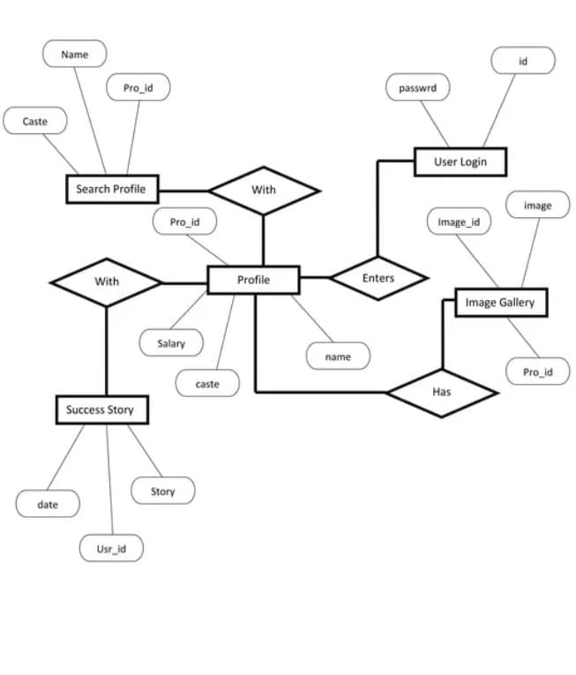

DFD DIAGRAM

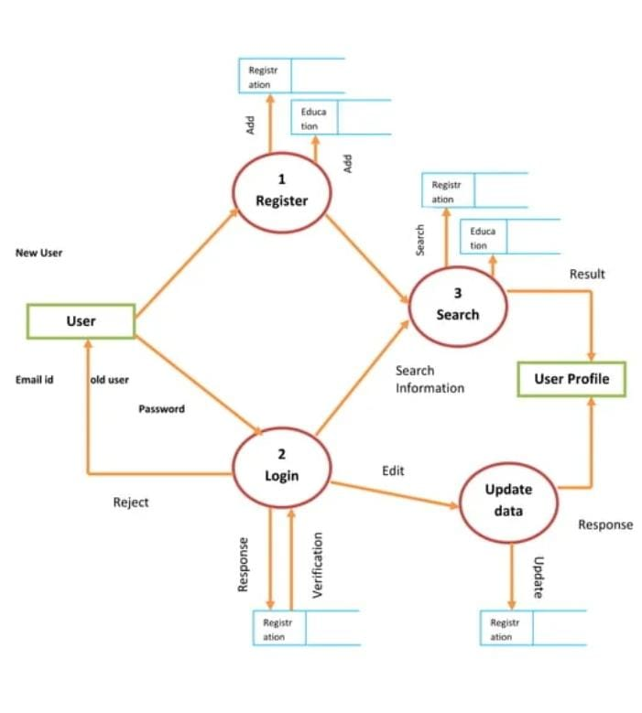

SCREEN LAYOUT

HOME PAGE

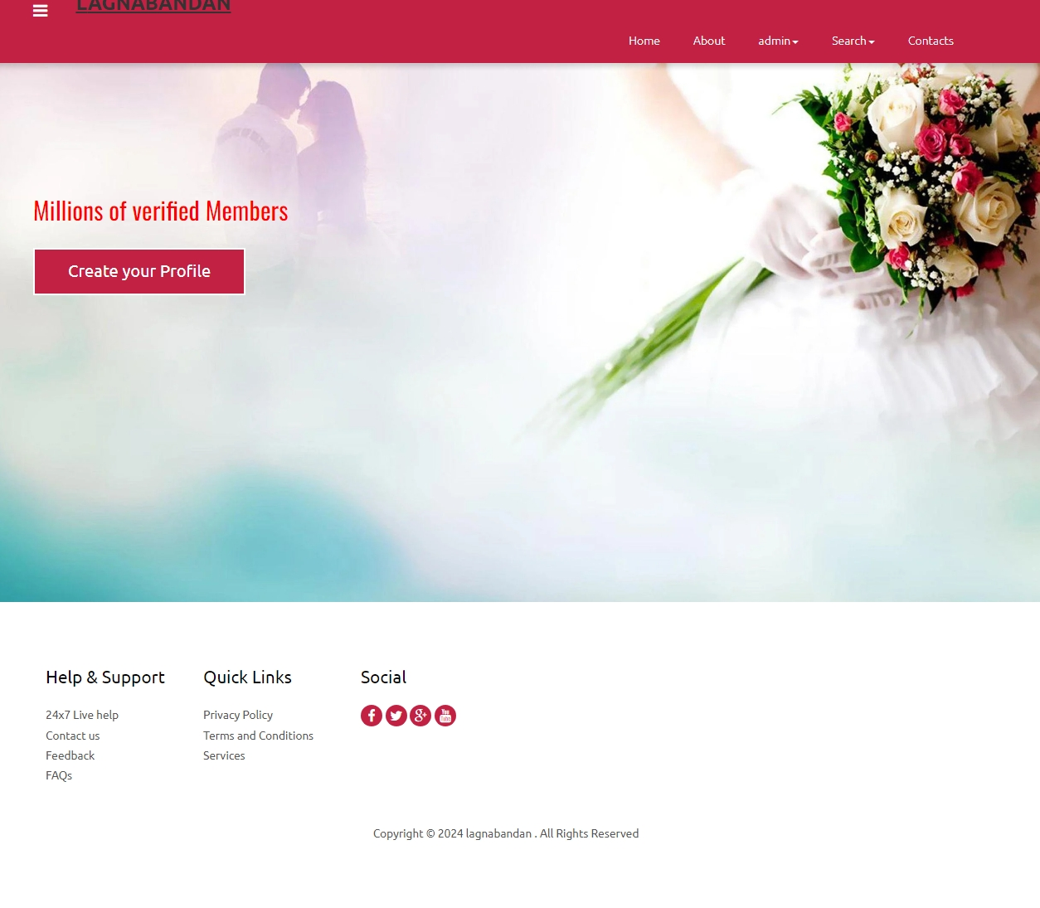

REGISTRATION PAGE

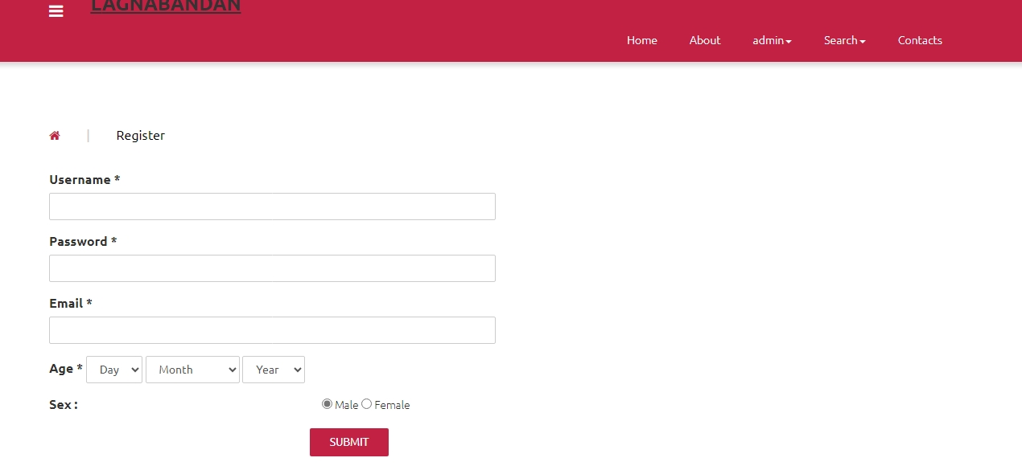

LOGIN PAGE

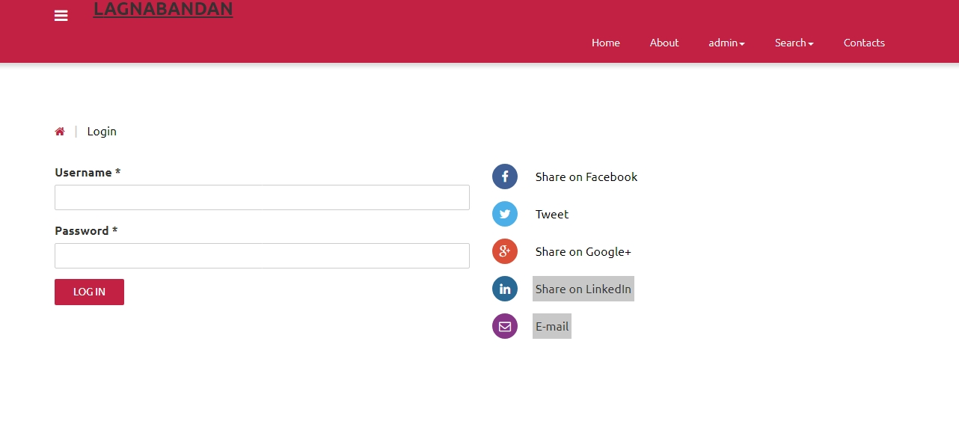

User home PAGE

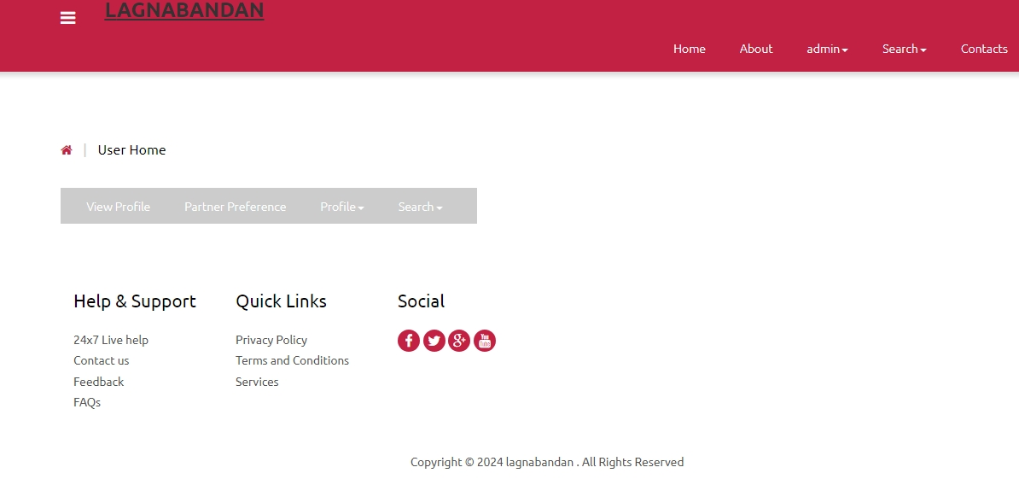

Contact page

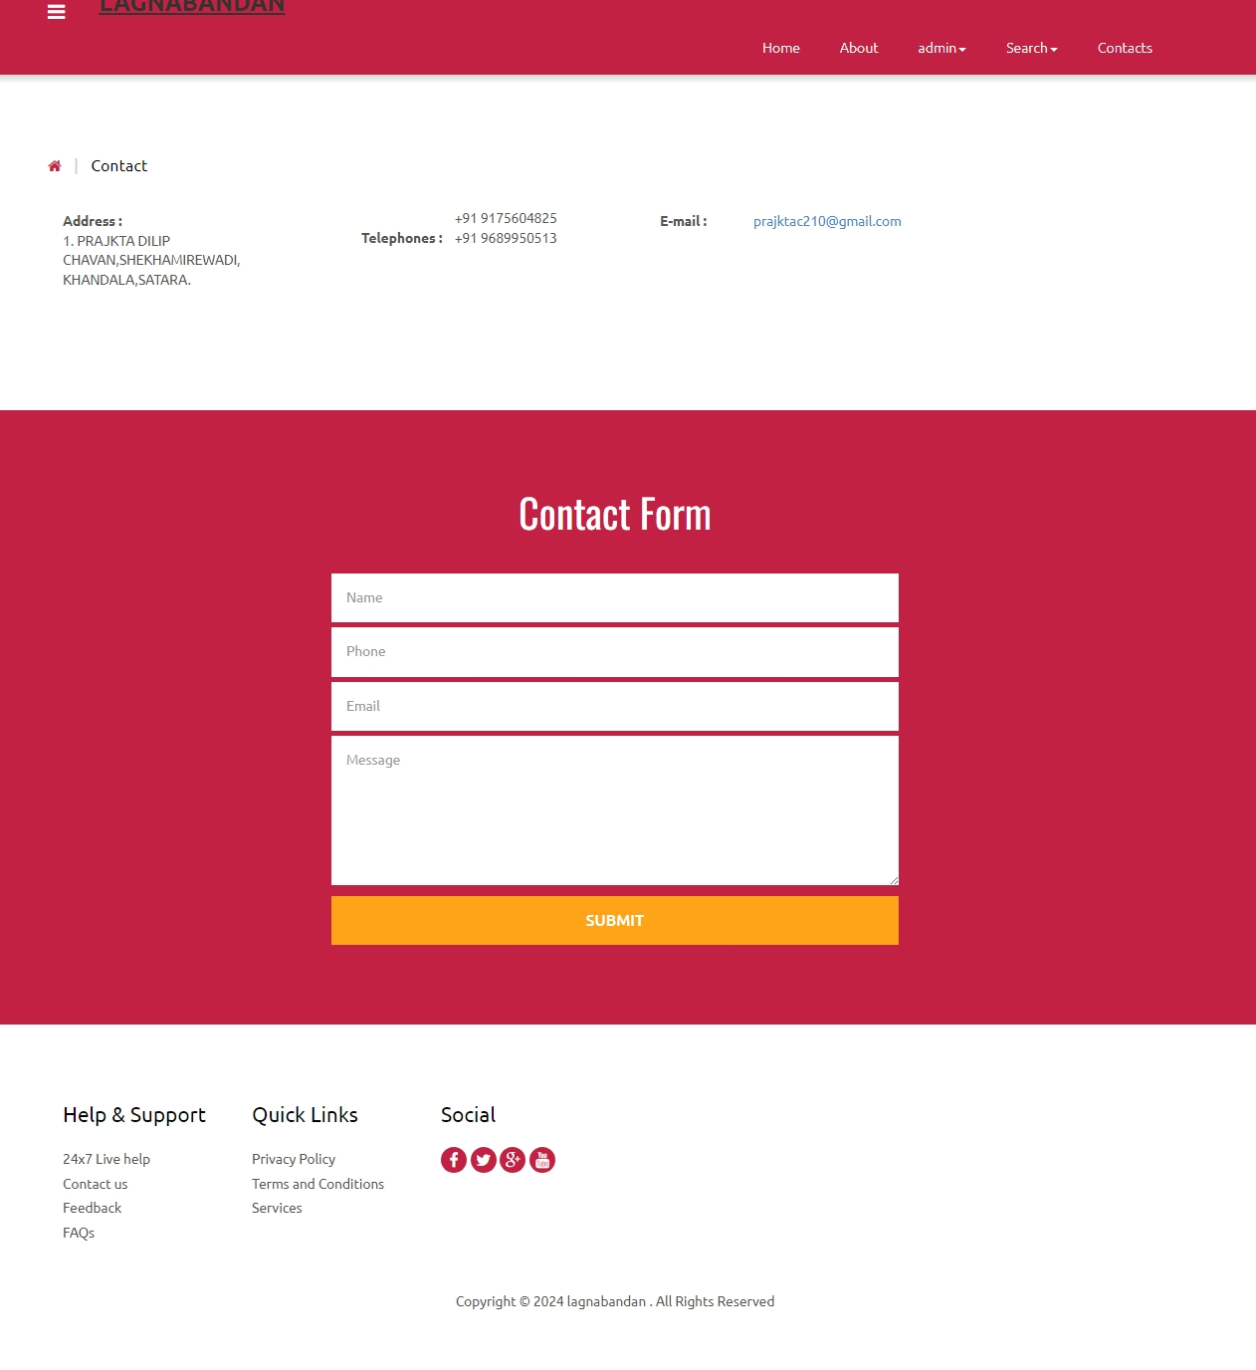

Regular search page

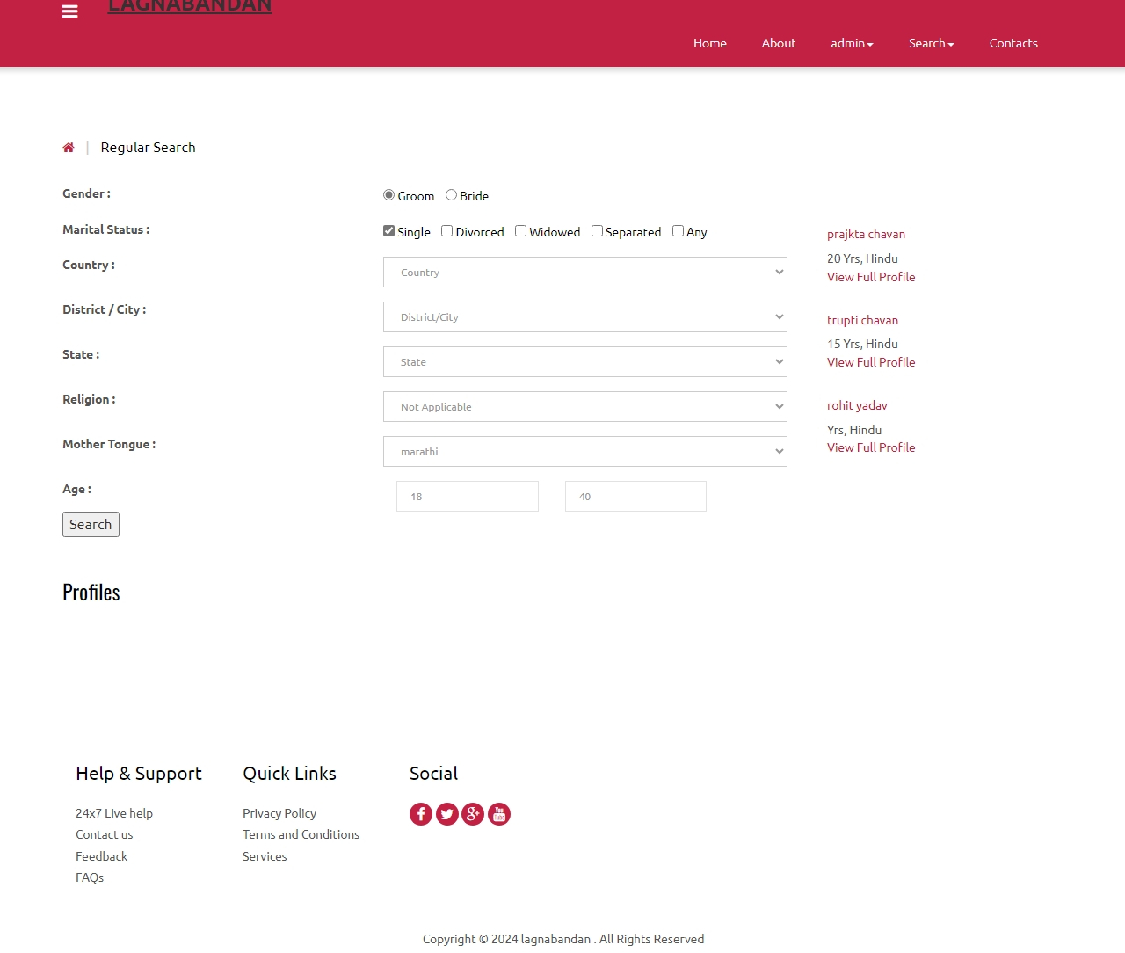

Search by id page

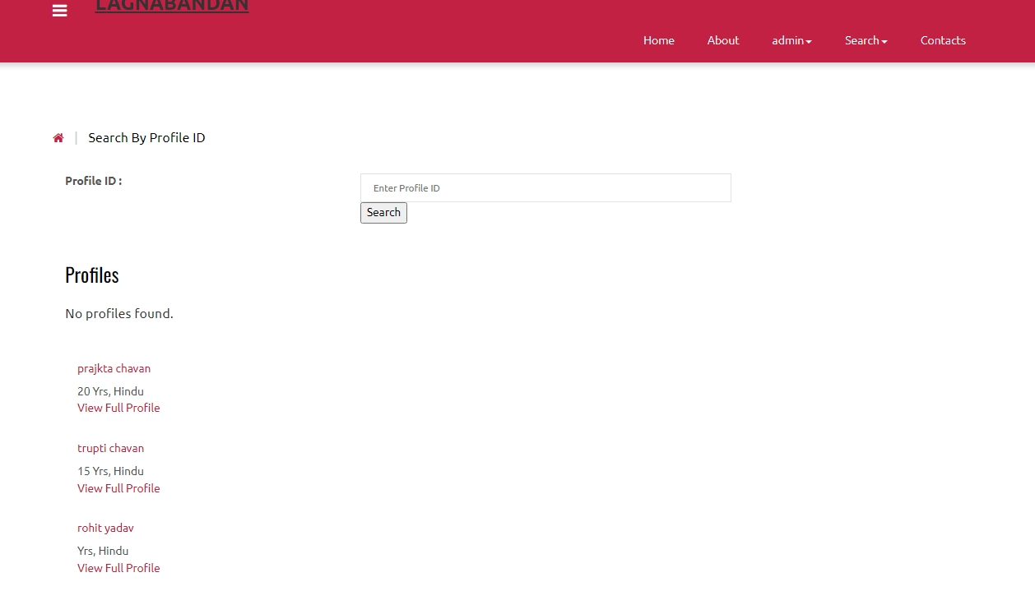

Create profile page

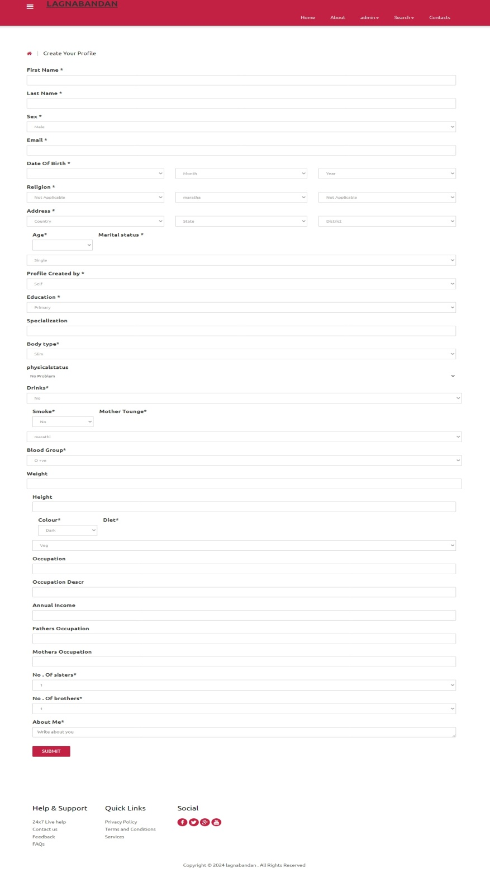

Faq page

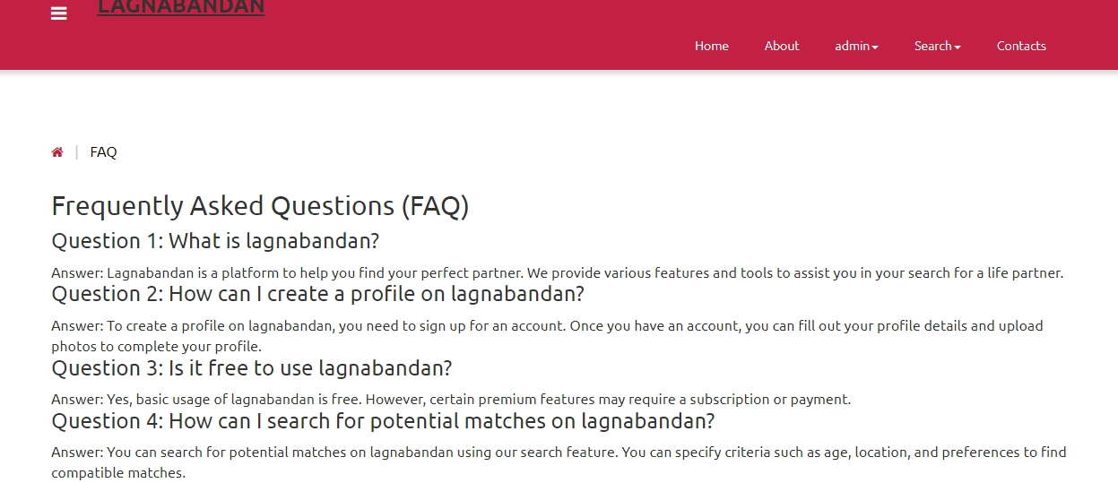

Partner preference page

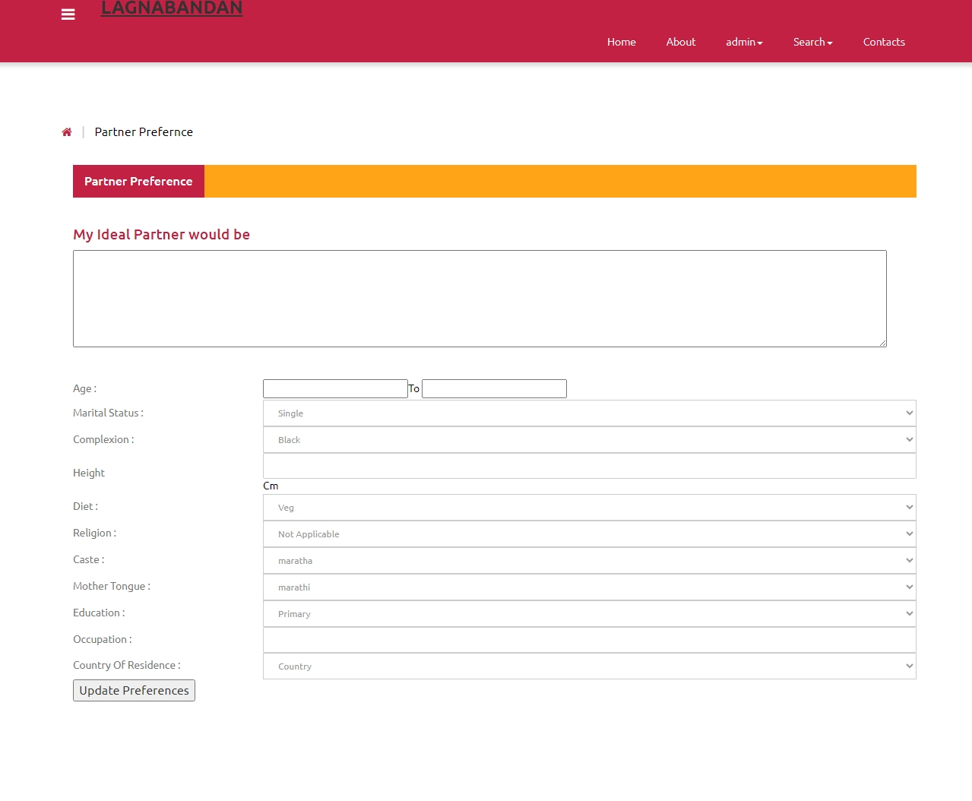

Thank you !!